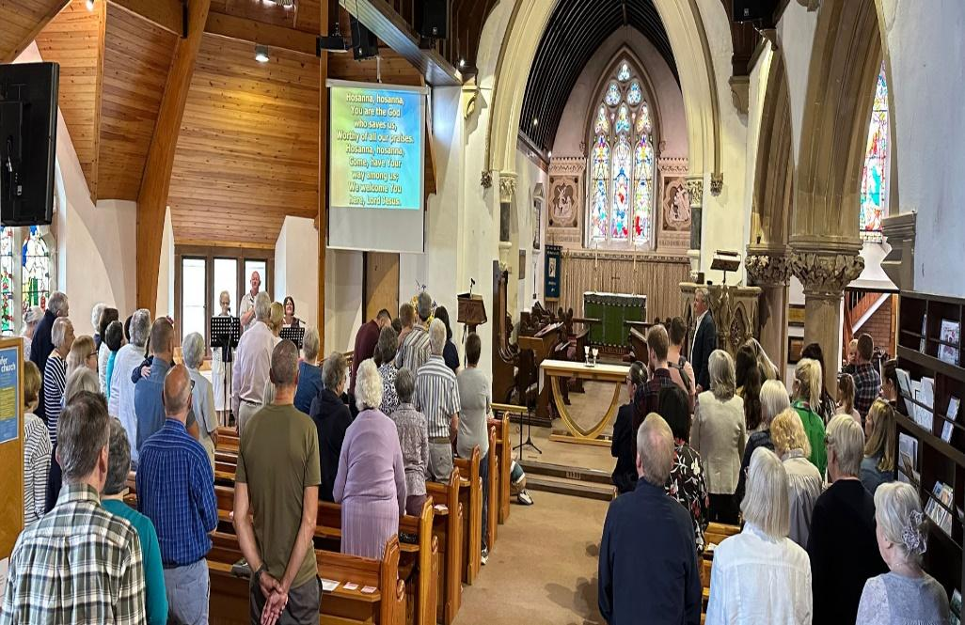
St Margaret’s Church
Whitnash

‘Receiving God’s love in Christ and sharing it with all’

Praying for His work in 2025
The Lord Jesus says ‘I will build my church’

December 2025

‘God is able to do more than we can ask or imagine’

St Margaret’s faces exciting challenges and opportunities in 2025 & beyond.
It is literally vital that everyone in our church family is fully involved in this – knowing what is happening and praying for the Lord Jesus to be glorified.

Please pray (especially at 11.30 each 1st Sunday)

Please join us from 11.30-11.45 am on the 1st Sunday of the month (in the Church building or remotely) and pray for the following
- For God to work powerfully through our Connect service.
- For our Homegroups to grow in breadth (size) and depth (godliness).
- That the Lord blesses our Churchwardens Steve Cort & Selina Doughlin-Bugg, Ministry Team and all others who serve in so many ways.
- For the Christmas services throughout December to point to Jesus clearly.
- The PCC fulfils our vision to serve the gospel by serving our parish and expanding our work and finances.
- For new leaders (homegroups, Flames & Rockets and Pioneers).
- For various Carol singing events in the parish throughout December, for lives to be singing God’s praises.
- For people to read Loving Whitnash and find true Christmas joy.
- For wisdom to conserve and use our buildings for God’s glory.
- For Bishop Sophie and the wider health of the CofE.

