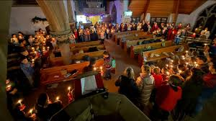
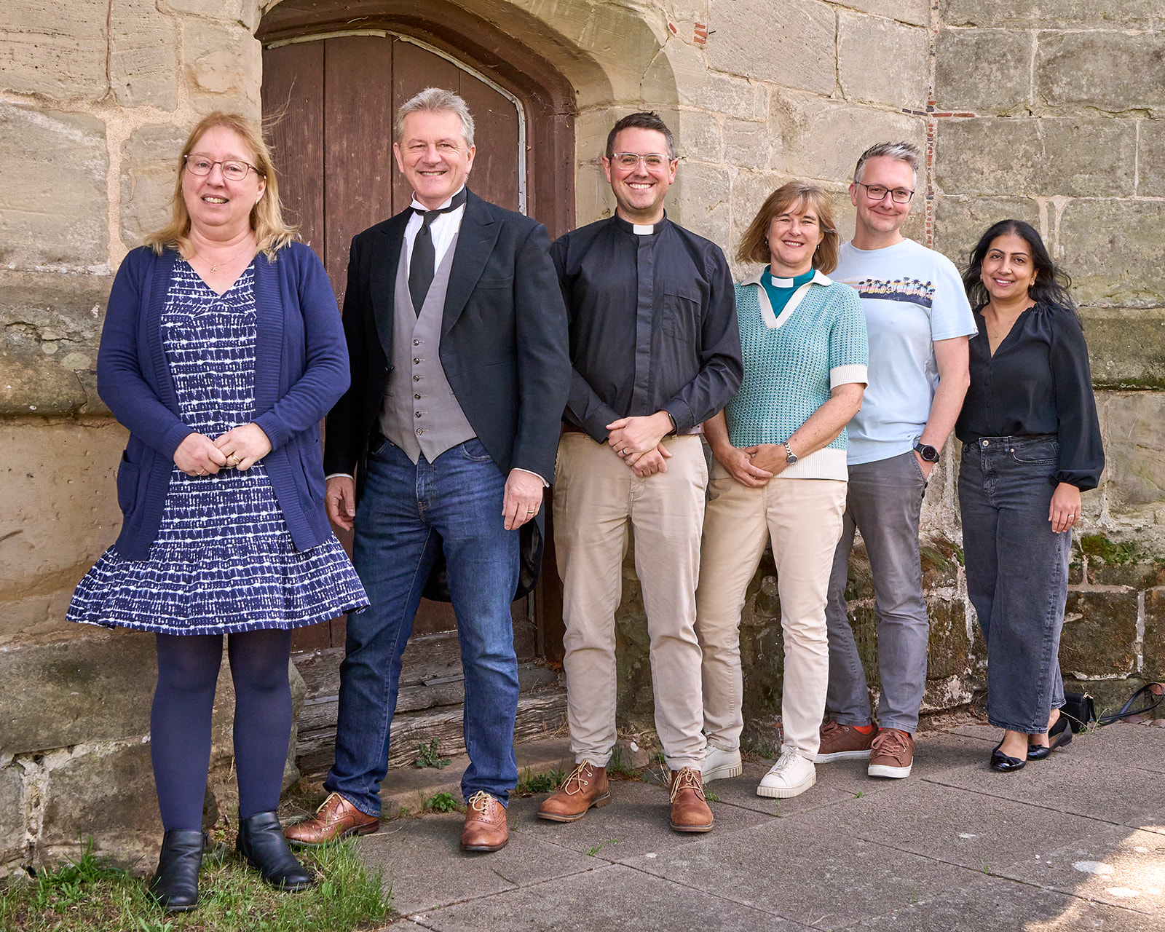
St Margaret’s Church
Whitnash

‘Receiving God’s love in Christ and sharing it with all’

Praying for His work in 2026
The Lord Jesus says ‘I will build my church’

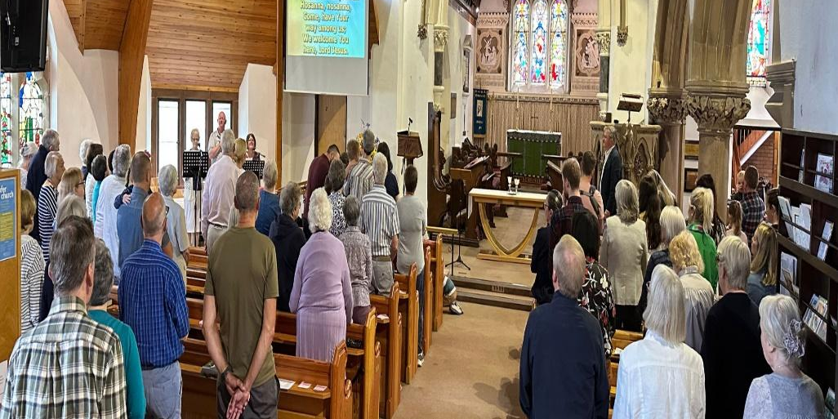

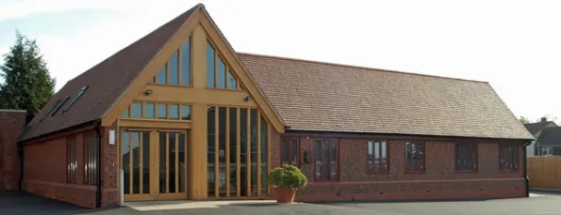
February 2026

‘God is able to do more than we can ask or imagine’
St Margaret’s faces exciting challenges and opportunities in 2026 & beyond.
It is literally vital that everyone in our church family is fully involved in this – knowing what is happening and praying for the Lord Jesus to be glorified.

Please pray (especially at 11.30 each 1st Sunday)
Please join us from 11.30-11.45 am on the 1st Sunday of the month (in the Church building or remotely) and pray for the following
- For God to work powerfully in our Connect & Encounter services.
- For our Homegroups, including a new afternoon one on Thursdays as well as those training as new leaders on Tuesday evenings.
- For the Lord to bless our Churchwardens Steve Cort & Selina Doughlin-Bugg, our Ministry Team and all others who serve.
- The Big Quiz on Saturday 7th February to support our Conservation project (focusing firstly on the much-loved Rose Window)
- The PCC fulfils our vision to serve the gospel by serving our parish and expanding our work and finances, including outreach events.
- For Rolene as she leads a new Bereavement course at Easter as well as our Pastoral care volunteers as they carry our love to many.
- For Pioneers & all Children’s work to be life-changing & good fun.
- That Loving Whitnash is helpful in the anticipation of Easter.
- For wisdom to conserve and use our buildings for God’s glory.
- For Bishop Sophie and the wider health of the CofE.

