**Sundays 6th & 13th July 2025**

**Our mission at St. Margaret’s is:**

**“To receive God’s love in Christ and to share it with all”**

**Website:** [**WWW.SMCW.ORG**](http://WWW.SMCW.ORG)

**Sunday 6th July**

10:00 a.m. **Morning Worship**

**Reading** Mark 6: 1-13

4:00pm **Connect @ 4** at the Church Centre

**Thursday 10th July**

10:30 a.m. **BCP Holy Communion**

**Sunday 13th July**

10:00a.m. **Holy Communion**

**Reading:** Mark 6: 14-44

4:00pm **Connect @ 4** at the Church Centre

**Thursday 17th July**

10:30 a.m. **BCP Holy Communion**

**COLLECTIONS AT SERVICES**: Please make your offerings on the wooden plates or on the ConnectTin machine, at the entry and exit doors to the Church, as we don’t pass the offertory plate around during the service. Many thanks.

**Prayers for people in need:** As you know, we are always available to add people to the list below so that we might pray for them, for healing. We intend for this long-term practice to continue but would ask that you let Anne know who you would like to be added, or to remain on this list. We will be starting a new prayer list from July 20th. If you would like a name to remain (with their permission) please let Anne know. That name will stay on for the following month unless we are asked for it to continue. Thank you.

**Your prayers are asked for the following people:**

Beverley Rye, Sophina Huggan, Alan Sperring, Ben Stafford, Julie Winup, Jeanette Oubridge, David Lloyd, Michael Roberts, Alistair McFarlane, Hallie-Rose, Avril Baker, Roger Perrin, Faye, Shirley Simms, Stuart Forrest, Paul Yarwood, Stewart Aitken

**For the bereaved family & friends of:** Diane Willis, David Robbins, Bill Wise, Audrey Marshall

**Requests for Foodbank donations:**

Tins of fruit, tins of vegetables (peas, sweetcorn), tinned potatoes, Custard, rice pudding, ketchup, mayonnaise, washing up liquid, Deodorant. With thanks for your continued support. Ros

**Foodbank job vacancy:** We are currently recruiting for a new session leader at St Mary's Church on a Wednesday. This is a paid role and if you or anyone you know has any questions regarding this advertisement or the job itself please do not hesitate to contact either Lynn Aston or Andy Bower, Operations Manager via [andy@warwickdistrict.foodbank.org.uk](mailto:andy@warwickdistrict.foodbank.org.uk).

**MISSION PRAYER***:* **Open Doors**

North Korea: Praise God for an elderly fieldworker who roams the woods in China to find North Korean escapees to help and share the Gospel with. He recently fell ill and doctors gave up on him, but he’s recovered enough to resume part of his ministry. Pray for continued fruit in old age.

Psalm 92 v14: “They will bear fruit in old age; they will stay fresh and green.” Thank you, Lord. Amen - Esther Brown Open Doors Rep

**FORTHCOMING MU Dates:**

15th July at 2pm...............**Cream Tea in the Chapter House** (£5 per person)

All are welcome.

No meeting during August.

**Summer 2025 Holiday Club**: 5th-8th August, 9:30am-2pm

For children in school years 1 to 6.

St. Margaret’s Church Centre. £20 per child. Lunch included.

Please visit the church website and fill in a form to register.

**The Bible Course:** Starts Tuesday 2nd September 7-9pm

This 8-week course at St Margaret's Church focusing on the Bible. We are hoping to stream the course live so that people can join in from home as well as in person. There is a £10 course book you need to buy to follow along with the course. Look out for the signup sheet

**If you’d like to add a notice in our newsletter, please contact Anne on:** [**anne@horsley.uk**](mailto:anne@horsley.uk)

**If you would like to be added to the mailing list to receive Church emails and/or the Newsletter please email Jay on** [**office.st.margc@gmail.com**](mailto:office.st.margc@gmail.com)

**Promoting a Safer Church:**

The care and protection of children, young people and adults involved in Church activities is the responsibility of everyone who participates in the life of the Church. If you are concerned that someone you know is at risk of or is being abused or presents a risk to others, please seek advice from a safeguarding advisor or if necessary, report the matter to the Local Authority Social care services on 01926 414 414.

**IF THERE IS AN IMMEDIATE RISK OF DANGER TO LIFE, PLEASE CONTACT THE POLICE ON 999.**

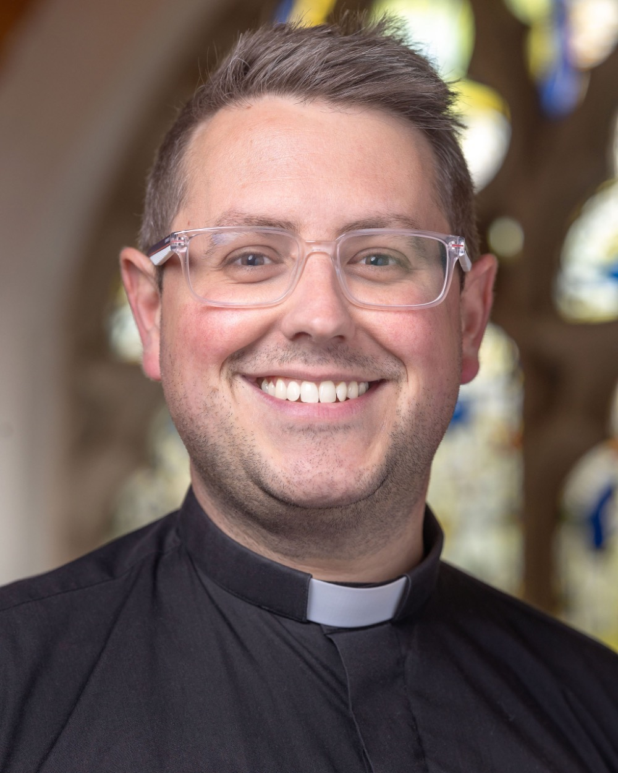**Name: Ben Cook**

**Role: Rector**

**Tel: 07545 309018**

**E:** [**ben.stmargc@gmail.com**](mailto:ben.stmargc@gmail.com)

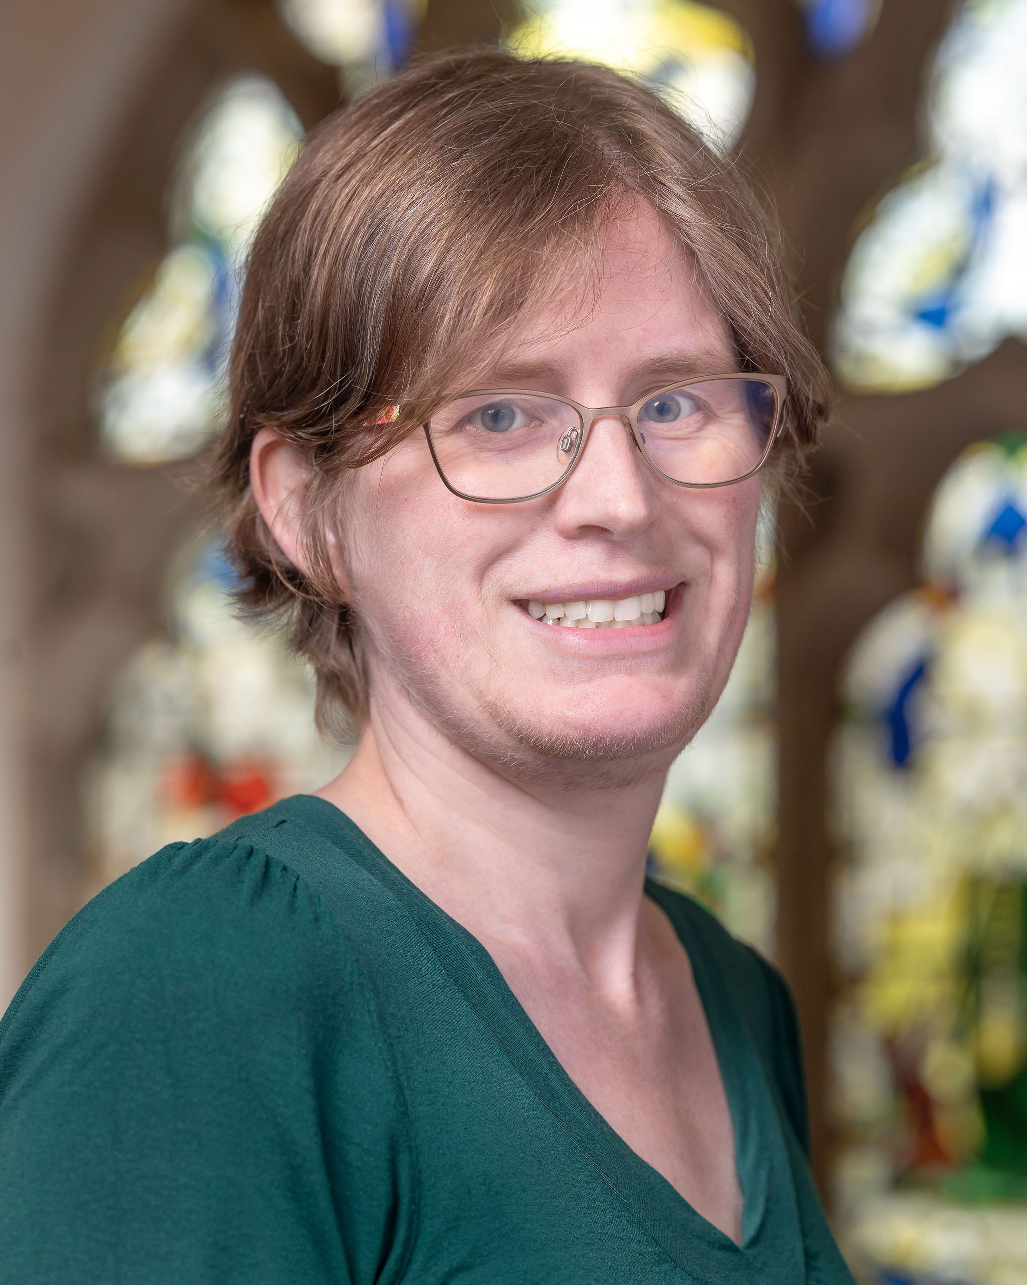**Name: Lyndsey Edmonds**

**Role: Parish Safeguarding Officer**

**Tel: 07763 804330**

**E:** [**pcc.safeguarding@gmail.com**](mailto:pcc.safeguarding@gmail.com)

**Name: Sarah Price**

**Role: Diocesan Safeguarding Officer**

**Tel: 02476 521345**

**E: safeguarding@coventry.anglican.org**